Soft Engineering
Project Plan

Group 4
CHIO HANG, CHEONG (Hang)
CHUN YIN, LEUNG (Marcus)
KWOK TO, MARTIN NG (Martin)
MIN GYE, PARK (Min)
YU FUNG, HO (Leo)

Plan outline
We chose to use Unity to develop this game. The project is planned to take 8 weeks (including Easter Holiday) with 6 stages, and every member should take part in at least two stages.
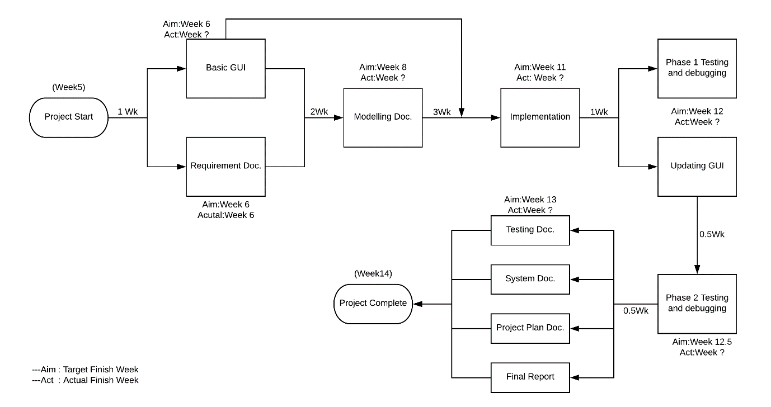
However, the project deadline is in week14, so this project should not be taken more than 9weeks.

Stage 1.1 – Basic GUI Design
Aim: Week 6 (Unfinished)
The GUI should be enough for testing game function by code writer.
Martin and Marcus are the GUI Designers.

Stage 1.2 – Requirement Documentation
Aim: Week 6 (Finished)
Min and Martin are responsible for Requirement Doc.

Stage 2 – Modelling Documentation
Aim: Week 8 (Unfinished)
Marcus and Hang are responsible for Modelling Documentation.

Stage 3 – Implementation
Aim: Week 11 (Unfinished)
Min, Leo, Hang are the code writers.

Stage 4.1 – Testing and Debugging (Phase 1)
Aim: Week 12 (Unfinished)
All members should be responsible for Testing and Debugging.

Stage 4.2 – Updating GUI Design
Aim: Week 12 (Unfinished)
Martin and Marcus should update/improve the GUI Design.

Stage 5 – Testing and Debugging (Phase 2)
Aim: Week 12.5 (Unfinished)
All members should be responsible for Testing and Debugging.

Stage 6 – Final Documentation
There are 4 documents in this stage:
Testing Document by Leo
System Document by all members
Project Plan by Leo
Final Report by Min

